RE TDSC-2021-09-0704, “Towards Neural Network-based Communication System: Attack and Defense”

Dear Editor,
Enclosed please find the revised manuscript “Towards Neural Network-based Communication System: Attack and Defense”. We thank you for handling the paper and thank the reviewers for their time and valuable comments. We have revised the paper in accordance with all the concrete comments.

- Major Modification
- We elaborate the overview of our proposed attack methods and defense mechanism in the Section 1 “Introduction”.
- In Section 3.1, Adversarial Neural Cryptography (ANC) system are explained with more details, which provides the application background for our proposed attack models and defense mechanism.
- We add explanations in Section 4 to clarify the vulnerability of ANC system,
- In Section 5, to clearly address the scenario and implementation of our proposed TMIM attack and TF attack, two illustrative examples are given in Fig. 2 and Fig. 4, the frameworks of attack models are presented in Fig. 3, and more details are added to concrete our attack description.
- In Section 7, we add explanations about the proposed defense mechanism to demonstrate why our defense mechanism can provide protection against proposed attacks.
- To improve the consistence and readability of this paper, we divide the original experiments section into two parts: validation of attack models in Section 6 and evaluation of defense mechanism in Section 8.
- We change some notations in this paper to fix notation abuse problem.
- We have carefully checked the presentation and polished the language in this paper.

In the following, we reply to the reviewers’ comments one by one.

- Reply to the comments raised by Reviewer 1

- Comment 1. The main content of this paper is built upon the ANC system, including the proposed attacks and corresponding defense. Thus, the building block ANC should be introduced clearly. For example, in page 3 line 12 “Moreover, Alice and Bob are readily used modules to take any given input for encryption or decryption with their held pre-shared key”. What is the meaning of any given input? Is there any requirement on the input format?
Reply: Thanks for the question.
In the ANC system, Alice is an encoding module, Bob is a decoding module, and Eve is an attack module. They are implemented as neural networks and trained by machine learning algorithms. For the purpose of secure communication, a sender can use the encoding module Alice to encode a plaintext p with a pre-shared key k and then transmit the corresponding ciphertext c to a receiver who can use the decoding module Bob to recover c with k and obtain the plaintext p_{Bob}.
Therefore, as common in machine learning methods, the trained models can be used on data that is similar to the training data or comes from the same distribution as training data. In the ANC system, the model is used on text data in binary bits; while in our work, we extend it to more complex image data. To clarify the statement, we also modify this sentence in this paper as “Especially, the encoding and decoding modules are readily used to take any given input for encoding and decoding with their pre-shared key, as long as the input data comes from the same distribution as their training dataset.” in Section 3.1.
There are some requirements on the input data format. As we explained in the Section 5, due to the property of neural networks, the input and network parameters are set to be continuous floating-point number for differentiability. Accordingly, every input plaintext should be pre-processed in continuous floating-point number for calculation. Details about data format can be found in Section 5.1.

- Comment 2. The prerequisite of proposed attacks is the adversary Eve can perform chosen plaintext attack, yet it is not mentioned how does Eve can achieve the chosen plaintext attack in this paper. This attack should be explained in detail.
Reply: Thanks for the valuable comment.
In the ANC system, Eve is an attack module used by the attacker. To explain the implementation of our proposed attack models, we add more explanations in Section 5.1 and Section 5.2 to describe how the chosen plaintext attack can be launched.
Once the training process is completed in ANC, the encoding module Alice is deployed on the sender side, and the decoding module Bob is deployed on the receiver side for communication. Because the pre-shared key is inside the encoding and decoding modules, any legitimate sender can directly use the encoding module Alice as a black-box to encode a plaintext and transmit to the receiver who can use the decoding module Bob as a black-box to decode the ciphertext.
Notice that the ANC system only considers eavesdropping attack at the training stage. That is, the attack module Eve can be only used for eavesdropping attack, in which attackers only know the ciphertext c for reconstructing p_{Eve} without any extra prior knowledge about the communications. Nevertheless, powerful attackers may exist and be able to obtain extra prior knowledge from various channels in real world. A practical scenario in crowdsensing is illustrated in Fig. 2.
Thus, the attacker can input specific data to encoding module and eavesdrop the encoded data to obtain the data pair (plaintext, ciphertext) as prior knowledge for chosen plaintext attack. More details can be found in the Section 5.1.

- Comment 3. In page 5, line 17, the operation of Generative TMIM attack is confused. Authors stated that “the generated ciphertext c = G(z|y)”, and then said that “assigning D(∙|y) different values, where ∙ can be either c or G(z|y)”, which is conflicting with previous statement. Because “c = G(z|y)” will give the same value for D(∙|y). Authors should carefully check the presentation.
Reply: Thank you for the valuable suggestions.
The statement in the previous version is a typo. We have checked and modified the description as follows.
“In our cGANs, the generator G takes a predefined random noise z ~ N(0,1) and condition y to output the generated ciphertext G(z|y); on the other hand, the discriminator D takes real ciphertext c or generated G(z|y) with label y as the inputs to differentiate whether its input data is real or fake by assigning D($∙$|y) different values, where $∙$ can be either c or G(z|y).”

- Comment 4. In Section 5.2, the framework in Fig. 2b does not match the description of Target Fraud Attack. The target fraud attack uses both distance based loss L_{d} and modification loss L(p, p’), but in the Fig.2b, only L_{d} is shown. Authors should change the figure accordingly.
Reply: Thank you for this comment.
Fig. 2(b) in the previous version is changed to Fig. 3(b) in the current version, where we add more details about each step in our mechanism. Specifically, we add the modification loss $L\left(p,p^{'}\right)={||p-p'||}_{n}$ in the figure to illustrate the loss function used by attacker.

- Comment 5. In the proposed defense method, key is separated from plaintext. Here, is the key freshly generated every time or a long-term key for certain sessions. How does these keys are generated?
Reply: Thank you for this comment.
The secret key used in our defense mechanism is freshly generated every session, and it is similar to the session key in traditional secure communication. The key will be re-generated when a new session is started. We added details of key generation in Section 3.1.
In the neural network-based communication problem, we adopt the secret key exchange method over a public insecure channel using neural networks, which follows the idea of neural cryptography. In the neural cryptography systems, two neural networks are trained on their mutual output bits synchronously. The two multi-layer networks start from random initial weights, learn from the output of each other, and obtain identical weights for both networks at the end of training process. Synchronization of neural networks can be considered as the stage for key generation, and the common identical weights of the two networks can be used as a key. We have added more details about key generation in Section 3 Preliminaries. The key generation methods have been studied in some existing works; while, in this paper, we mainly focus on the design of neural networks for communication and thus just directly apply the existing key generation methods.
To clarify the process of more key generation details, here, we list the core steps of the key generation method in reference [1] as follows:
(i) initialize two neural networks at both sides of communication;
(ii) feed the same input to both networks, calculate output, and exchange output of each other over insecure communication channel;
(iii) update the two networks based on mutual output;
(iv) repeat (ii) and (iii) until synchronization (around 10~100 exchange);
(v) use the weight parameters of the common identical networks under synchronized state as the session key.
The generated key can be used a long-term shared secret as that in traditional session key. If a new session key is need, the same operations in (ii)-(v) are conducted to generate a new session key.
[1] I. Kanter, W. Kinzel, and E. Kanter, “Secure exchange of information by synchronization of neural networks,” EPL (Europhysics Letters), vol. 57, no. 1, 2002, pp. 141–148.

- Comment 6. Some notations might need to be changed:
a. The loss functions in Eq. (1) and Eq. (2) have the same name but different representation.
b. Somewhere c is used as ciphertext, but other places use c’ instead.
c. L is used as loss function and the length of key.
Reply: thank you for this comment.
a. We have changed the formula in Eq. (2) to fix this typo.
b. In this paper, c represents real ciphertext, and c’ represents adversarial ciphertext generated by attacker. We have corrected the notation abuse.
c. We have changed the notation of loss function to make it clear to read.
Besides, we have carefully checked the entire paper and fix grammar mistakes and typos.

- Comment 7. The reviewer suggests the authors to carefully proofread the paper and fix the grammatical errors. This would help improve readability.
Reply: Thank you for the comment.
We have polished the language and fix all grammar mistakes in this paper.

- Reply to the comments raised by Reviewer 2

- Comment 1. The threat models of both two attacks should be better justified.
(a). For the first attack, namely Target Man-in-the-Middle (TMIM) attack, the authors assume that the adversary Eve is able to have the ability to send any plaintext to Alice and obtain the corresponding ciphertext. The authors are suggested to better explain/justify this assumption in the real-world setting. Specifically, the author should discuss the real application scene where the sender Alice can be queried by the adversary.
(b). Similarly, for the second attack, namely Target Fraud (TF) attack, the adversary crafts the original plaintext with an adversarial plaintext to mislead the identifier at the receiver side. Given a plaintext, the adversary selects an adversarial plaintext in the target class with the minimum distance loss, which is the sum between plaintext distance and ciphertext distance. However, in the settings of an adversarial neural communication system, the adversary can only get access to the encoded ciphertext. Even if the adversary has a set of plaintexts and can query Alice with them, it is not realistic for Eve to know the original plaintext encoded by Alice. The authors should better explain this strong assumption to make the paper convincing.
Reply: Thanks for the valuable comments. We add more explanations to clarify our attack models.
(a). Once the training process is completed in ANC, the encoding module Alice is deployed on the sender side, and the decoding module Bob is deployed on the receiver side for communication. Because the pre-shared key is inside the encoding and decoding modules, any legitimate sender can directly use the encoding module Alice as a black-box to encode a plaintext and transmit to the receiver who can use the decoding module Bob as a black-box to decode the ciphertext.
Notice that the ANC system only considers eavesdropping attack at the training stage. That is, the attack module Eve can be only used for eavesdropping attack, in which attackers only know the ciphertext c for reconstructing p_{Eve} without any extra prior knowledge about the communications. Nevertheless, powerful attackers may exist and be able to obtain extra prior knowledge from various channels in real world. A practical scenario in crowdsensing is illustrated in Fig. 2, where the ANC system is adopted for data transmission. The task workers use the encoding module Alice to encode their sensory data and send the encoded contents to the task server, while the task server can run the decoding module Bob to get the decoded data. Assume task worker 1 is malicious and intends to attack on task worker 2’s transmission. Under this situation, task worker 1 can perform chosen plaintext attack (CPA) by inputting multiple plaintexts p into the encoding module and then eavesdrop their corresponding ciphertexts c. With these paired plaintexts and ciphertexts (p, c) as prior knowledge, task worker 1 can infer or extract important information about the encoding module to break the entire ANC system. By eavesdropping the communication channel of task worker 2, task worker 1 can replace the original encoded data c by an adversarial sample c’ and send it to the task server to realize TMIM attack.
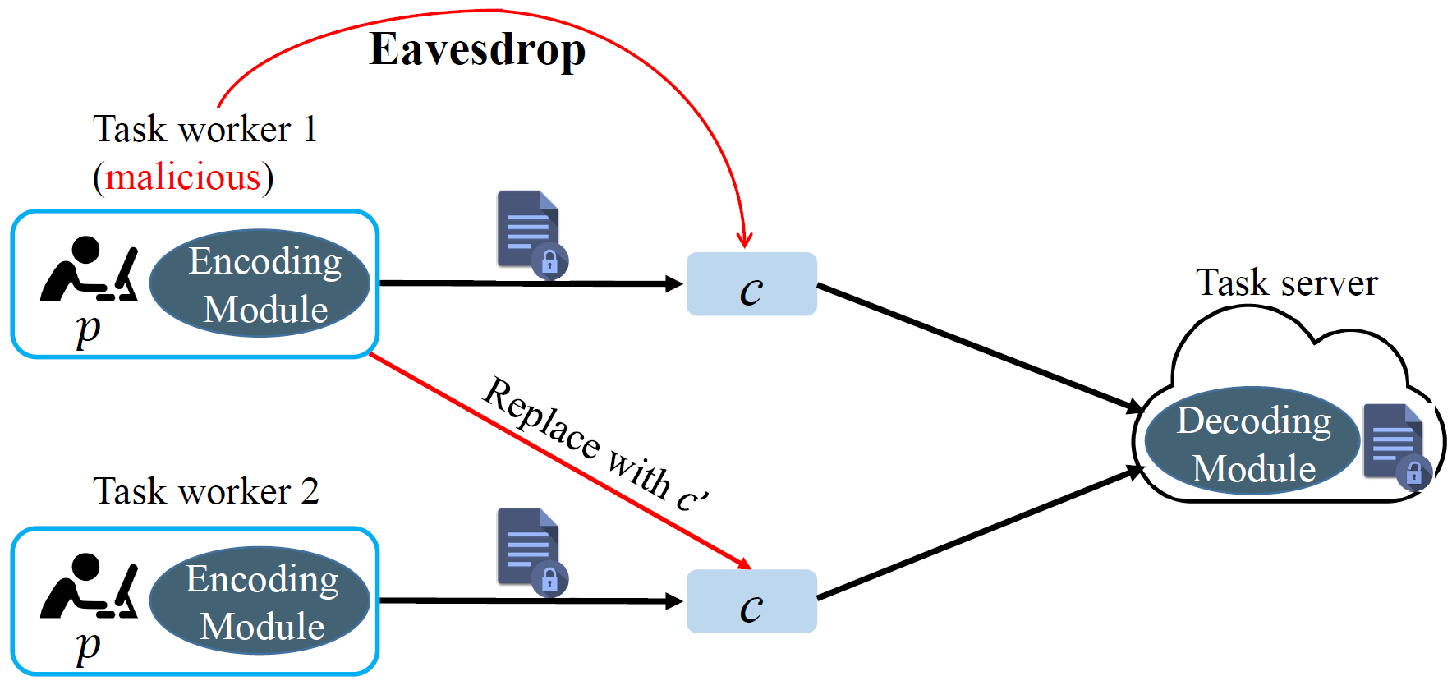
Fig. 2: The threat model of TMIM attack in crowdsensing scenario
To better justify the implementation of both two attack models, we add more details in Section 5.1 and 5.2 with description and illustrative examples.
(b). Target fraud attack (TF attack) is proposed to attack a different part of the ANC system: the input plaintext p of encoding module.
As we illustrated, the ANC communication system can be applied in real applications such as data transmission or data collection, where the encoding module Alice is deployed at the sender side, and the decoding module Bob is deployed at the receiver side. Ideally, the data p sent from the sender should be the same as the data p_{Bob} received by the receiver through communication. Assume that there is a stronger attacker who has the ability to use the encoding module Alice to encode data and eavesdrop the encoded ciphertexts. In addition, the attacker can modify the original data to crafted-but-imperceptible adversarial data such that the adversarial data sent from sender is totally different from the recovered data at the receiver side. In this case, the integrity of ANC system is broken. For example, as shown in Fig. 4, in a crowdsensing system, the task worker could be malicious to perform such an attack by modifying his/her original data p to the adversarial data p’ through our designed TF attack method. Then, the malicious task worker can encode the modified data p’ through the encoding module Alice, and finally the task server decodes data with the decoding module Bob and obtain an adversarial data of target class, instead of the original data’s ground truth class.

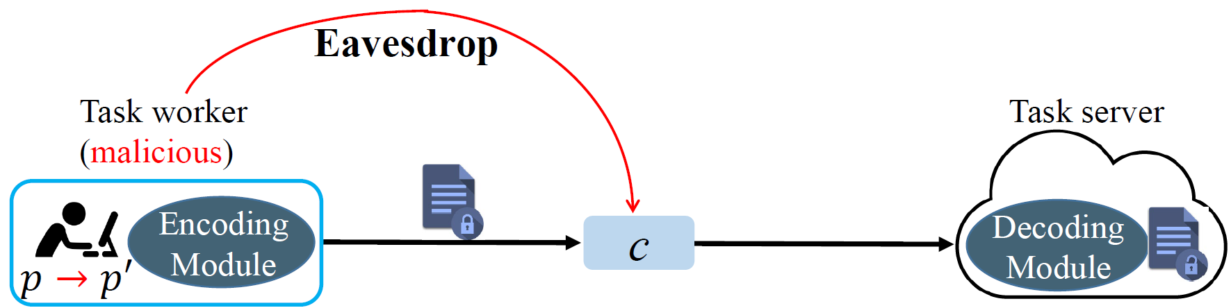
Fig. 4: An example of TF attack in crowdsensing scenario
We add more explanation of threat model in Section 5.2 and corresponding illustrative figures.

- Comment 2. The settings in the defense method are not consistent with that in the attack. In the threat model in Section 5, the adversary Eve is assumed to have the ability to query the sender Alice and can thus implement the chosen-plaintext attack. However, in the defense section, the attacker is deprived of this ability and is assumed to proceed chosen-plaintext attack using a fake key, which is not mentioned in both attacks. Such inconsistency invalidates the defense method against the proposed attacks.
Reply: Thanks for the comments. We revise our description to avoid confusion.
In the setting of ANC system, Alice is an encoding module used by sender, Bob is a decoding module used by receiver, and Eve is an attack module used by attacker. The attacker in our defense mechanism can still perform chosen plaintext attack via using Eve, but the success rate may be reduced. The main reason is that the key is generated inside the encoding module in the ANC system but is separated from the encoding module in our proposed system.
In the ANC system, the attacker can query the encoding module and implement chosen-plaintext attack because the key for encoding and decoding is inside the encoding and decoding modules. Thus, the encoding module is similar to a black-box for all users to encode data. Then, through chosen plaintext attack, the attacker can obtain information easily from paired data (p, c) and perform following TMIM attack and TF attack. Obviously, the way to put encoding module and key together in ANC is not safe enough.
Therefore, to overcome this security weakness of ANC, we separate the key k and encoding/decoding modules in our proposed defense mechanism, so that the encoded/decoded result is correct only when correct key is provided. The introduction of separated key k improves security, because even the encoding module has the same structure, different senders with different keys can make the different encoded results.
In our defense mechanism, the attacker still has ability to query the encoding module to implement the chosen plaintext attack. As discussed in Section 7: Notably, at the sender side, both the plaintext p and the key k are needed to run the encoding module in the encoding processes. To query the encoding module and proceed chosen plaintext attack towards our proposed defense system, the attacker should input p_{Eve} and his key k’ to the encoding module Alice and get c_{Eve} = Alice(p, k’). In our system, the secret key is separated from the encoding/decoding module, and every user has his distinct key, so the key k’ used by the attacker may not be equal to k. Consequently, the attacker’s ciphertext c_{Eve} may not be the same as the correct ciphertext c unless the attacker tries the correct key k out.” Due to the different keys in our defense mechanism, it becomes harder for the attacker to get correct data pair (p_{Eve}, c_{Eve}) through chosen plaintext attack, because the correct key k of victim may not be the same as the attacker’s key k’.
In conclusion, our proposed defense mechanism improves the ANC system by setting separate secret key, so that the impact of chosen plaintext attack is mitigated.

- Comment 3. In the TMIM attack, the adversary replaces the original ciphertext by the mean of adversarial ciphertexts with the target label or the adversarial sample generated by a GAN model. However, as the adversary can query the sender as well as to replace the ciphertext, (a) why not just directly send an adversarial ciphertext to Bob? (b) Is it necessary to take the mean value of a set of adversarial samples? (c) Can the mean of the adversarial samples always be identified in the target class? (d) Also, the author claims that the induce of GAN is for the sake of improving the diversity of reconstructed plaintext at Bob's side. However, since the goal of the neural communication system is to transmit data in a safe and accurate way, why is the diversity of the reconstructed data important?
Reply: Thanks for this comment.
In the ANC system, Alice is an encoding module used by sender, Bob is a decoding module used by receiver, and Eve is an attack module used by attacker. After this explanation, we answer the reviewer’s question one by one.
(a) Yes, the attacker can also directly send the adversarial ciphertext to the receiver’s decoding module to fulfill the attack. But this is another kind of attack that directly sends malicious information to the receiver. In our proposed attack models, we focus on the attacker who aims at manipulating the captured ciphertext sent by sender.
(b) There are many ways to generate adversarial ciphertext. Taking the mean value of a set of samples is just one way we choose. Sending an individual adversarial sample to the receiver may also achieve the same purpose. The reasons we pick mean value of samples are as follows: (i) in the field of machine learning, neural networks are used to learn the statistic properties and distribution features of data, and the mean value of samples can show the averaged data statistics or features of a data class; (ii) the mean value of samples will not be impact by some abnormal individual data or outlier data point.
(c) For the reconstructed adversarial samples of the same mean value, they are identical as we have shown in the experiment results in Fig. 5, which may lead to suspect of the receiver. Thus, we adopt the generative TMIM attack that can produce different adversarial samples.
(d) Although the goal of the neural communication system is to transmit data in a safe and accurate way, the primary target for attackers is to achieve their desired attack purposes. As we have explained in the above question, receiving identical adversarial samples may cause suspicious by the receiver because the data should not be identical in real world with such a high probability. Therefore, we introduce the GAN-based attack for ciphertext manipulation with certain diversity.

- Comment 4. In the TF attack, the paper says the attack goal is to cause Bob to get a different reconstruction result from p’ in the second paragraph in Section 5.2. However, from Definition 2 in Section 5.2, the attack goal is to make reconstruction result different from p while same as p’. Regarding the first claim is a typo, I cannot see the system is actually being attacked in terms of communication since Alice sends the ciphertext encoded from the adversarial plaintext p’ and B recovers it.
Reply: Thanks for this question.
In the ANC system, Alice is an encoding module used by sender, Bob is a decoding module used by receiver, and Eve is an attack module used by attacker. After this explanation, we answer the reviewer’s question.
There is a typo in Definition 2 of Section 5.2 and we have fixed it. Originally, a plaintext p is encoded by the sender with the encoding module Alice through c=Alice(p, k) and sent to the receiver for decoding Bob(c, k)=$p_{Bob}$. When there is no attack, a well-functioned communication system can guarantee that the semantic information of p and $p_{Bob}$ is the same: ${I\left(p\right)=I(p}_{Bob})$. When TF attack happens, the attacker first finds an adversarial example p’ that is similar to the original plaintext p in terms of semantic information, i.e., $I\left(p\right)=I(p')$. Then, the adversarial example p’ is encoded by the encoding module Alice through c=Alice(p’, k) and decoded by the decoding module through Bob(c, k)= $p_{Bob}$. After the communication, the semantic information of $p_{Bob}$ is different from the transmitted data p’, i.e., ${I\left(p'\right)≠I(p}_{Bob})$, which causes mistake in the communication system.
Generally speaking, TF attack happens before the communication but is expressed after communication. An experimental figure in Section 6 can explain this attack well:
The first figure is original data p, the second figure is p’ that is modified from p by attacker and sent to receiver, and the third figure is decoded data p_{Bob} recovered by the receiver. We can see that the adversarial sample p’ sent by the sender is different from the recovered data p_{Bob} by the receiver.
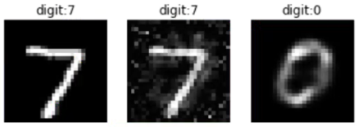

- Reply to the comments raised by Reviewer 3

- Comment 1. I think authors could elaborate more on their approach and their contribution in the Introduction section. It would be beneficial if authors explain the overview of their attack and defense algorithms. Furthermore, the authors could mention some key results of their work in the Introduction section.
Reply: Thanks for these valuable comments.
We have reorganized the introduction section and added more description about the proposed attack approaches and defense mechanism. Also, some key results of our work are summarized in this section to improve the readability.

- Comment 2. It would be more organized if authors present the result of attack experiments before introducing their defense mechanism. Currently, all the experiments are in one section.
Reply: Thanks a lot for the comment.
In the revised version, we divide the original experiments section into two parts: validation of attack models in Section 6 and evaluation of defense mechanism in Section 8. More specifically, validation of attack models (Section 6) is moved after introducing the proposed attack methods (Section 5), and evaluation of defense mechanism (Section 8) is presented following the defense mechanism (Section 7).

